

PEACE-WORK-FATHERLAND

MINISTRY OF HIGHER EDUCATION

UNIVERSITY OF BUEA

PAIX-TRAVAILE-PATRIE

MINISTERE DE L’ENSEIGNEMENT SUPERIEUR

UNIVERSITE DE BUEA

**UNIVERSITY OF BUEA**

**FACULTY OF ENGINEERING AND TECHNOLOGY**

**DEPARTMENT OF COMPUTER ENGINEERING**

**CEF 440: INTERNET PROGRAMMING (J2EE) AND MOBILE PROGRAMMING**

***DESIGN AND IMPLEMENTATION OF A MARKET MANAGEMENT SYTEM***

GROUP MEMBERS

|  |  |
| --- | --- |
| **NAME** | **MATRICULE** |
| GAMUAH PADJINOU RYANE JOY | FE20A044 |
| NDALEGH NOELA LUM MBAH | FE20A070 |
| FORMASIT CHIJOH FOKUNANG | FE20A041 |
| RACHEAL NKONGHO TAFONGOH | FE20A100 |
| MOSONGO ADINA SAKWE NANGERI | FE20A066 |

**COURSE INSTRUCTOR**:

DR. NKEMENI VALERY

Thursday, 27th April 2023.

**TABLE OF CONTENTS**

1. UML DIAGRAMS
   1. Use Case Diagram
   2. Class diagram
   3. Activity Diagram
   4. Sequence Diagrams
      1. Add Product
      2. Search Product
      3. Shop Registration
      4. Buyers Interaction
      5. Product Advertisement
   5. Data Flow diagram

UML DIAGRAMS

It is indispensable that the different UML diagrams describing the flow of the product be designed. They provide a template to understand and follow, from which the product proper can be developed.

**Use Case Diagram**

It presents a graphical depiction of user’s possible interactions with the system. It shows the various use cases and the different users the system has, showing their interactions. It describes the high-level functions and scope of the system, but not how the system operates internally.

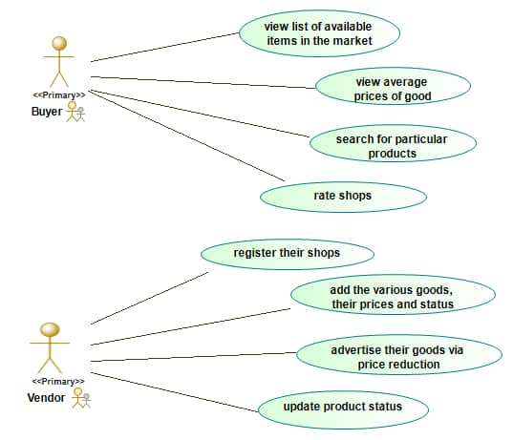

**Class Diagram**

This is the blueprint of the system. It models the objects that make up the system, displays the relationships between them, and describes what those objects do and the services that they provide. It is basically a graphical representation of the static view of the system and represents the different aspects of the application.

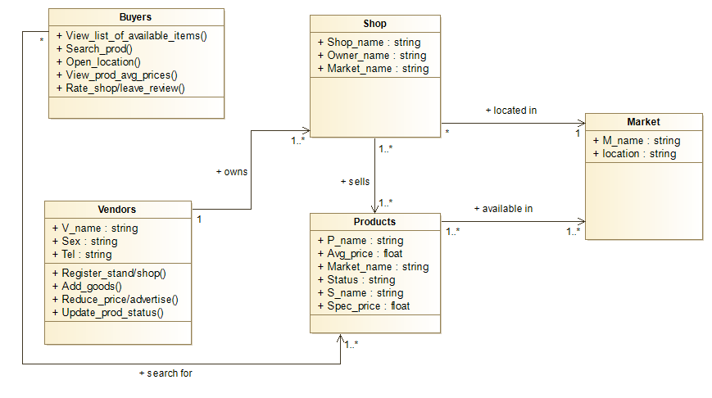

**Activity Diagram**

It visually presents a series of actions or flow of control (from one activity to another) in the system. It describes the steps in the use case diagram. It depicts the workflow from start point to finish point.

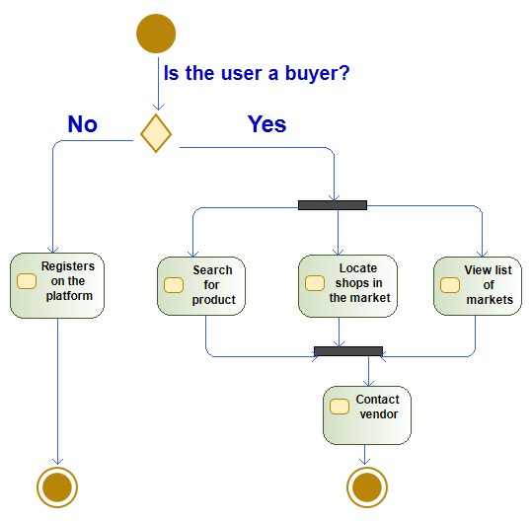

**Sequence Diagrams**

These diagrams describe how - and in what order – a group of objects work together. They are important in aiding to understand the system requirements or document a process. They show the process interactions arranged in time sequence.

Represented below are major sequence diagrams which cover the scope of the project.

**Add Product**

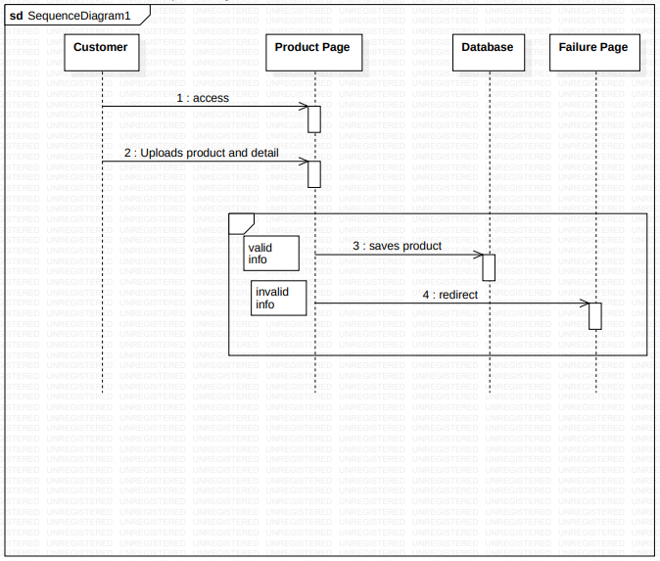

**Search Product**

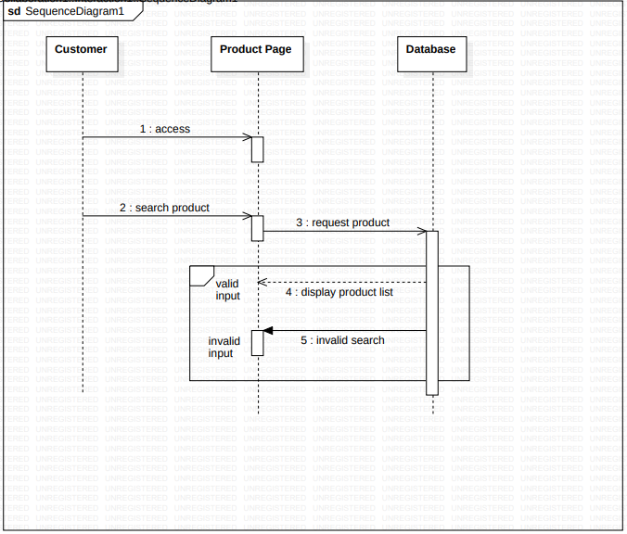

**Shop Registration**

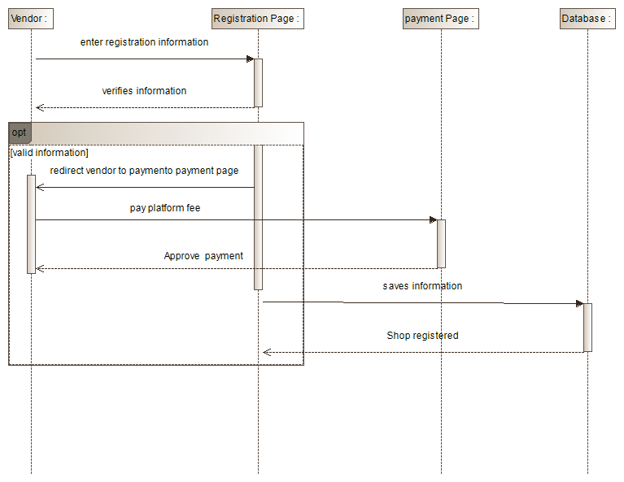

**Buyers Interaction**

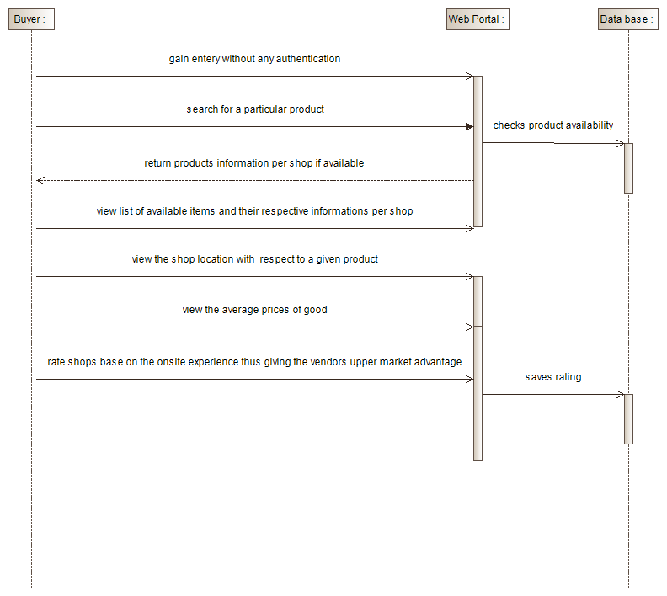

**Product Advertisement**

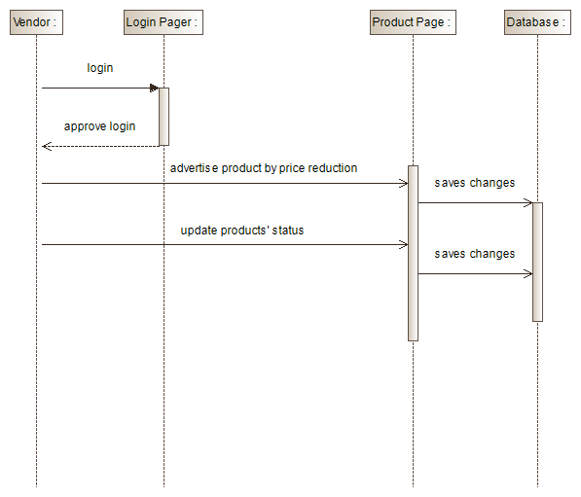

**Data Flow Diagram**

A Data Flow Diagram (DFD) maps out the flow of information for any process or system. It provides information about the outputs and inputs of each entity and the process itself. It also includes data stores and the sub-processes the data moves through. The DFD for this system is shown below;

